Period Promise – email to past participants; product or financial collection (or both)

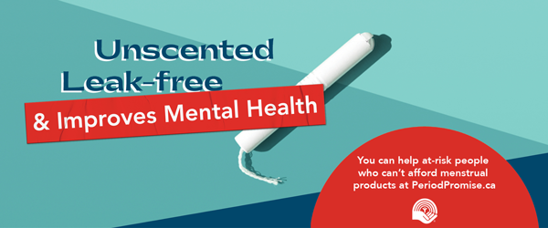

Hello Team,

It’s that time of year again and <<insert org name>> is taking part in the 2022 United Way Period Promise Campaign. Our campaign will be a little closer to what it typically looks like but we’re keeping all the good bits that came about last year, including the ability to donate online and combining our campaign for both product and monetary collections.

Periods are a fact of life. If you’re living in poverty – or otherwise vulnerable – accessing necessary menstrual products can be challenging. But when people have access to menstrual products, it improves their health and well-being, gives back dignity, and makes it possible for them to stay engaged in their community.
Joining United Way’s Period Promise campaign is one way we can help build healthy, caring and inclusive communities. Running a collection campaign or making a donation is a quick way to make a big difference! Let’s help ensure that everyone can live with the dignity we all deserve.

We will be running our Period Promise campaign from May 6 to June 7, 2023. We will be collecting period products in the office; please drop them off in the box at reception. You can also give financially, if you prefer, by clicking here United Way's Period Promise Campaign 2022 - Central Alberta - JustGiving

With the help of thousands of donors, United Way has been able to distribute more than 2 million menstrual products to community organizations across the province. They are making it easier for everybody to access the product they need when they need it. Let’s help improve the health and well-being of people and make it easier for them to stay engaged in their communities by helping with United Way’s Period Promise campaign.

With thanks,
<<insert name>>

Period Promise – email to new participants; product or financial collection (or both)

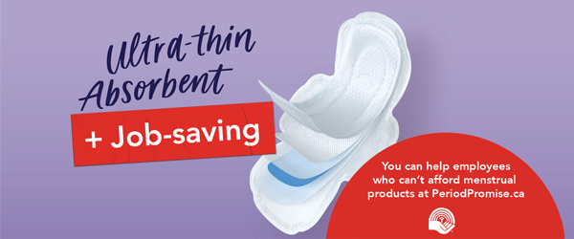

Hello Team!

You may have heard that <<insert org name>> is going to participate in the United Way Period Promise Campaign. What is Period Promise?

Periods are a fact of life. If you are living in poverty – or otherwise vulnerable – accessing necessary menstrual products can be challenging. And the financial pressures because of COVID have continued to increase vulnerability.
Too many people miss out on social events when they have their period (things like accessing the library or the pool, or missing days of work) because the risk of entering a public space without the products they need is too great. Not having the menstrual products needed puts limits on life and can make staying connected to community difficult.
But when people have access to menstrual products, it improves their health and well-being, gives back dignity, and makes it possible for them to stay engaged in their community.
Joining United Way’s Period Promise campaign is one way we can help build healthy, caring, and inclusive communities. Running a collection campaign or donating is a quick way to make a significant difference! Let’s help ensure that everyone can live with the dignity we all deserve.

We will be running our Period Promise campaign from May 6 to June 7, 2023. We will be collecting period products in the office; please drop them off in the box at reception. You can also give financially, if you prefer, by clicking here United Way's Period Promise Campaign 2022 - Central Alberta - JustGiving

With the help of thousands of donors, United Way has been able to distribute more than 2 million menstrual products to community organizations across the province. They are making it easier for everybody to access the product they need when they need it. Let’s help improve the health and well-being of people and make it easier for them to stay engaged in their communities by helping with United Way’s Period Promise campaign.

With thanks,
<<insert name>>

Subsequent Campaign Emails

Email #1

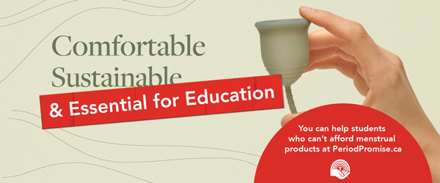

Hello Team!

We are well into our Period Promise Campaign – thank you very much to those who have had a chance to donate and/or bring in period products. Here is some quick information from United Way, just so that you have a sense of just how important this project is in Alberta and BC.

- 26% of people who menstruate in BC say that they have gone through a period without having menstrual products available to them
- 13% of people who menstruate in BC say that, as dependents, their families have not been able to afford menstrual products on their behalf
- 30% of people say that they haven't known where to access menstrual products they could afford when their period has hit.

Last year, United Way released the results of their Period Promise Research Project, which were shocking. Some of the information they collected included anonymous testimonies about what people do when they do not have the product they need when they need it. I pulled this one out for you:

“I had to make a choice between food and menstrual products at the grocery store yesterday. I knew I had one pad at home, my period had just started, and I’m banking on a light period so that I can eat and still be able to make it through my period. If something leaks through, I’m not sure what I’ll do. I’ll probably have to borrow from a friend.”

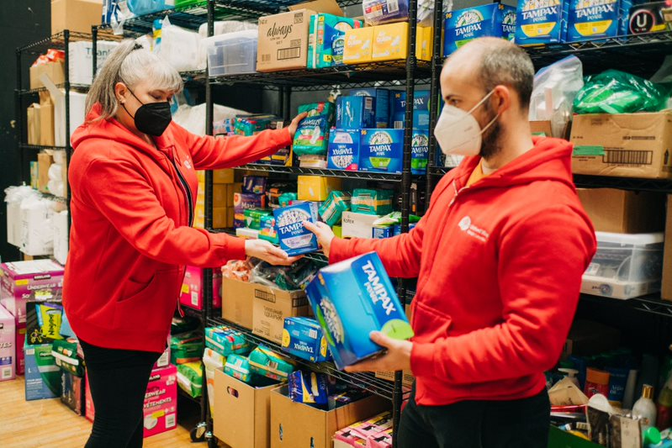
Stocking shelves in the North Shore Neihbourhood House with donated products.

If you haven’t yet had a chance to participate in our campaign, please click on the link United Way's Period Promise Campaign 2022 - Central Alberta - JustGiving to do so.

Kind Regards,
<<insert name

Email #2

Hello Team!

We’re half-way done with our campaign, and we wanted to share some more information with you about the impact that United Way’s work on Period Promise has in community.

Too many families miss out on social events, going to the library or the pool, because it is easier to stay home than risk bleeding in public. Not having the product you need when you need it can make staying connected to community difficult.
      - 29% missed community events
      - 27% missed social events
      - 18% missed school
      - 22% missed work

By donating to United Way’s Period Promise, you will be helping the many individuals with stories like these:

“When I can't afford enough menstrual products, I can't go out. I was unable to go to the food bank or to a casual job (I'm disabled) because I bled for two weeks and didn't have enough pads.”

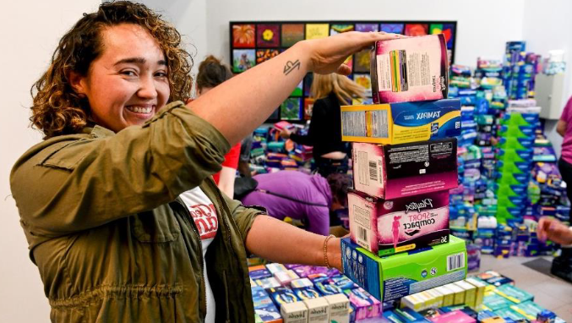
United Way staff and volunteers packaging donations to send out to community agencies.

“When playing sports in school or going on field trips, or being a competitive swimmer, as well as a swimming coach, lifeguard, and instructor, I frequently found myself in awkward situations whereby I didn’t have enough products or know when I might need products... I wanted to be recognized for my hard work and commitment, and I wanted to have the same access to what I needed to compete and meet my potential as an athlete, and sometimes I just had to exit the situation before completing what I wanted/needed to do.”
Let’s make a difference and help improve the health and well-being of people, making it easier for them to stay engaged in their communities and strengthen vital connections. If you haven yet had the chance, please consider donating and click the link here United Way's Period Promise Campaign 2022 - Central Alberta - JustGiving.

Kind Regards,
<<insert name>>
Email #3

Hello Team,

Campaign is three quarters through, and we have done an amazing job so far. Thank you to everyone who has donated through the website or brought products in (or both!)!

As you know by now, there are many people struggling and too many people are missing school or leaving work because they cannot afford to buy the products they need, and they are not freely available where they are needed.

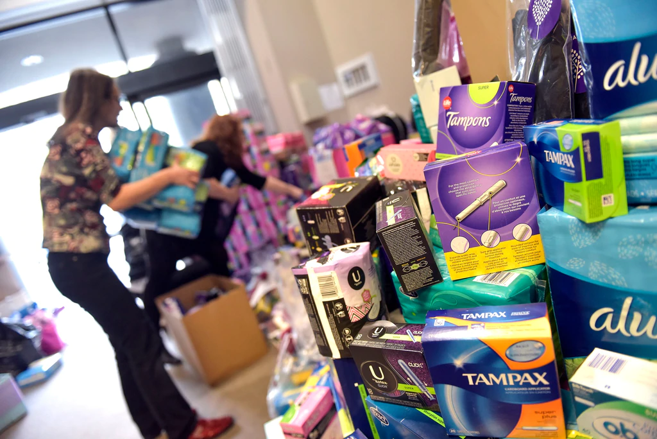
United Way staff and volunteers packaging donations to send out to community agencies.

Menstruation is one of the top two reasons that people who menstruate miss work; for many working in low-income positions, that’s because they cannot afford to buy the product that they need. And it is more common than you would think. During their research project, United Way gathered hundreds of stories just like this one:

“I've missed work because the only thing to use was folded up toilet paper, I need to change that very often and am afraid of moving and having it fall down my pant leg. I've even lost jobs because I take time off once a month.”

Let’s be a part of the solution. Together, we can tackle period poverty and make our community more accessible for everybody. Here is our unique website link to donate. Thank you so much for your support.

Kind Regards,
<<insert name>>

Email #4

Hello Team,

As campaign draws to a close, we wanted to say thank you so much for all your contributions. We are so thrilled that we will be able to provide:
- xx tampons
- xx pads
- xx liners
- xx reusable products
- $xx in donations

Because of your generosity, United Way Central Alberta will be able to help the many people in our communities who face the added challenges of homelessness, living with a disability, or just the stigma around having a period at all. People who are embarrassed to ask for help.

Because of your contribution, stories like these will be fewer and fewer:

“I was homeless as a teenager and later, I was a low-income single mother. I remember doing everything I could to make my supplies stretch- when I was homeless, I would often steal tampons after trying to find some for free. When I was a young, poor single mother, every penny spent was towards my daughter- I would bus for hours to try to find free menstrual supplies. I would use old rags. I would wear a tampon for way, way longer than I should've. It was food for my baby or tampons, so I chose food for my baby.”

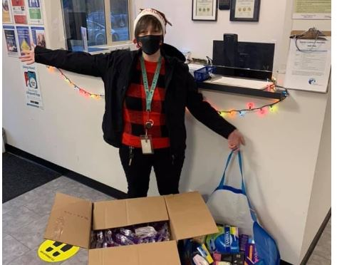
A United Way volunteer delivering a hamper full of menstrual products to a community agency on behalf of the Period Promise campaign!

Once again, thank you for your kindness and generosity. We are helping build the vital connections that help make our communities stronger.

Kind Regards,
<<insert name>>

Additional Information

Periods don’t stop for pandemics, and COVID-19 has made affording menstrual products more difficult for tens of thousands of Albertans. Job losses mean that there are more people than ever who are struggling to purchase the menstrual products that make it possible for them to be involved in their community.

Women make up most Canada’s minimum-wage and part-time workers (working poor), and work in industries at higher risk of lay-off during COVID-19: cooks, servers, cleaners, travel industry, hospitality, retail, childcare (https://canadianwomen.org/blog/the-difficult-economic-side-effects-of-covid-19-for-women/)

- “As COVID hit, women lost 62 per cent of the jobs shut down in February and March across Canada, almost all in the service sector, many in low-wage sectors like retail, hospitality, and personal services… That translated into one in every six jobs for women.” (Financial Post)
- In April 2020, employment for women in BC decreased by 147,500 positions (14%), compared to employment for men at a decrease of 131,200 positions (11.4%), with major losses in service industry, accommodation, food services, wholesale, and retail (https://www2.gov.bc.ca/assets/gov/data/statistics/employment-labour-market/lfs_highlights.pdf)
- In April 2020, more than 55,000 women in BC were pushed out of or otherwise left the workforce, which isn’t reflected in the unemployment numbers (which only records people who are actively looking for work) https://www2.gov.bc.ca/assets/gov/data/statistics/employment-labour-market/lfs_highlights.pdf

“‘Menstruators are home, in quarantine, and places like schools, shelters, and community centers, which provided access to period products, are now closed to the public. Menstruators now have the burden of providing these products for themselves. Which begs the question, if one in five teens in the U.S. have struggled to afford period products [according to State of the Period] or were not able to purchase them at all, where are they supposed to get them now?’ says Days, of Hate the Dot.” (Teen Vogue)

“Period poverty was already a major issue globally. However, due to financial strain, reduced access to products and an increase in the price of products people are suffering more.“ (Forbes)

