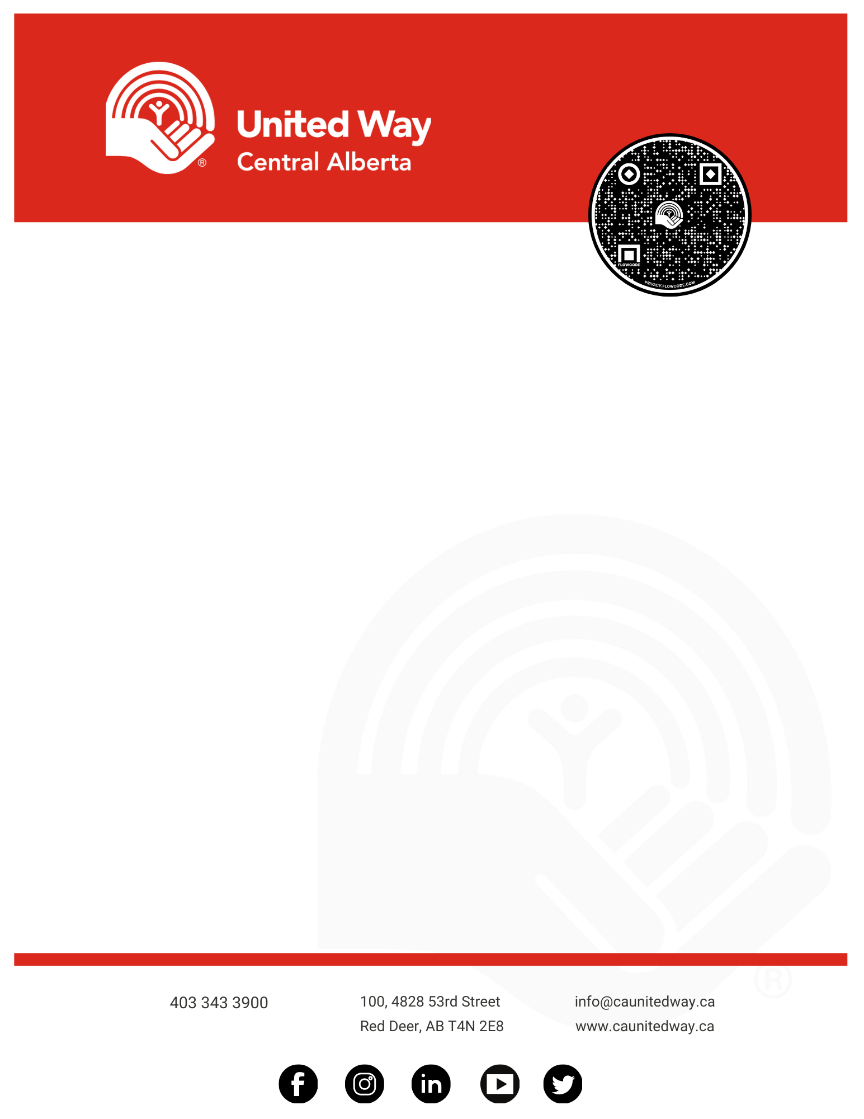

Innisfail, Alberta – United Way Central Alberta (UWCA) is pleased to announce the launch of a new Period Promise Pilot Project for the Town of Innisfail.

This pilot includes six dispensers for free menstrual products and enough products for the entire year in washrooms at the library, recreation centre and arena. Funding for the pilot project has been provided by an Innisfail Community Grant of $2800. The Soroptimist International of Central Alberta have also stepped forward and donated $600 as well as advocacy to the pilot. United Way will cover administration costs.

UWCA CEO Brett Speight said “Period Poverty is a very real issue faced by many, preventing them from taking part in many activities as they normally would such as school, sports, work, and other activities. This should not be the case and access to menstrual hygiene products should be like toilet paper.”

“Importantly, much of the pilot will focus on gathering information from the community on the impacts of having access to hygiene products and educate the community in this important issue,” Speight continued.

Innisfail and area businesses are invited to join the movement to sign the Period Promise Policy and provide free products in their facilities.

For more information, contact

Chelsea O’Donoghue

403-347-0513 or [chelsea.odonoghue@caunitedway.ca](mailto:chelsea.odonoghue@caunitedway.ca)

**Period Promise Pilot Project Kicks Off Today in Innisfail**

April 26, 2022