Period Promise – email to new participants; product or financial collection (or both)

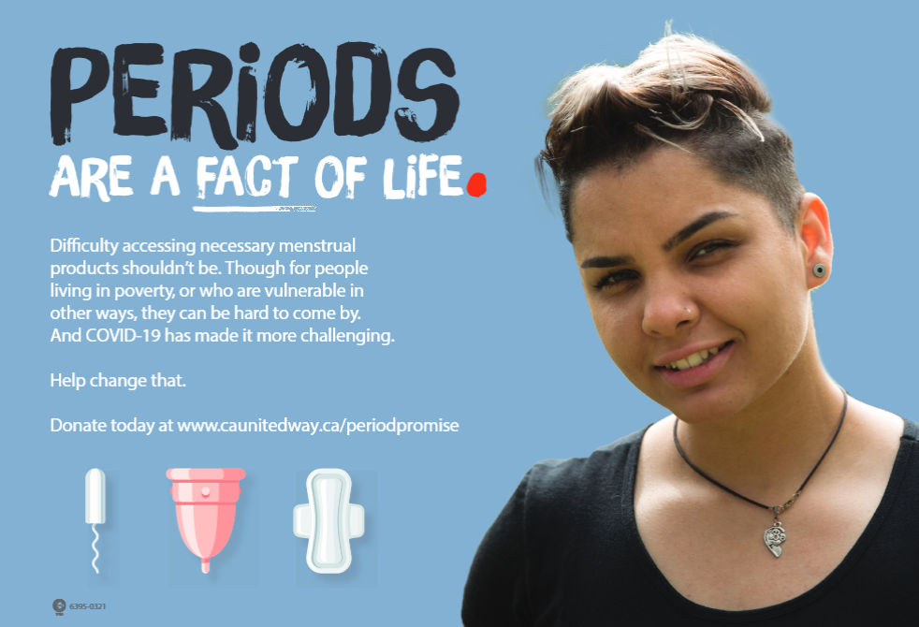

Hello Team!

You may have heard that <<insert org name>> is going to participate in the United Way Period Promise Campaign this year. What is Period Promise?

Not having the product you need when you need it can make staying connected to community difficult.
Too many single mothers must choose between buying tampons or food for their families. Too many trans and non-binary kids are scrambling silently in washrooms, putting together makeshift pads that do not suit their needs. And too many families miss out on social events because it is easier to stay home than risk bleeding in public.

To put it simply, too many people are missing out on life because they don’t have easy access to menstrual products.

The Period Promise campaign by United Way asks us to be a part of the solution. Together, we can tackle period poverty and make our community more accessible for everybody.

We will be running our Period Promise campaign from May 1 to 28, 2021. We will be collecting period products in the office; please drop them off in the box at reception. You can also give financially, if you prefer, by accessing our unique URL https://www.justgiving.com/campaign/UWCAPeriodPromise2023
If you want to do more than donate, and help spread the word - you can also set up your own Period Promise Fundraiser on JustGiving to share with your workplace, social and family connections. It’s easy! Just click the ‘Start Fundraising’ button on the campaign page linked above.

With the help of thousands of donors, United Way has been able to distribute more than 2 million menstrual products to community organizations in Canada and we’re excited to bring this important initiative to Central Alberta. We are committed to making it easier for everybody to access the product they need when they need it. Let’s help United Way reach an even higher goal this year to help improve the health and well-being of people and make it easier for them to stay engaged in their communities.

With thanks,
<<insert name>>

Subsequent Campaign Emails

Email #1

Hello Team!

We’re well into our Period Promise Campaign – thank you very much to those who have had a chance to donate and/or bring in period products. Here’s some quick information from research released this spring from United Way Lower Mainland, just so that you’ve got a sense of just how important this project is.

- 26% of people who menstruate say that they have gone through a period without having menstrual products available to them
- 13% of people who menstruate say that, as dependents, their families have not been able to afford menstrual products on their behalf
      - 30% of people say that they haven't known where to access menstrual products they could afford when their period has hit.

United Way released the results of their Period Promise Research Project, which were pretty shocking. Some of the information they collected included anonymous testimonies about what people do when they don’t have the product they need when they need it. I pulled this one out for you:

“I had to make a choice between food and menstrual products at the grocery store yesterday. I knew I had one pad at home, my period had just started, and I’m banking on a light period so that I can eat and still be able to make it through my period. If something leaks through I’m not sure what I’ll do. I’ll probably have to borrow from a friend.”

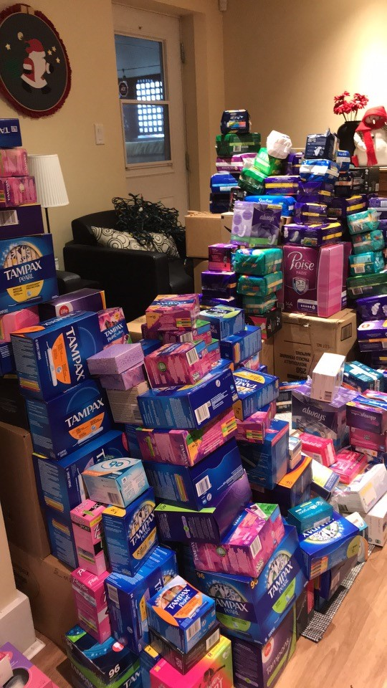
A collection of products at a community member’s home in November 2020!

If you haven’t yet had a chance to participate in our campaign, please click on the link https://www.justgiving.com/campaign/UWCAPeriodPromise2023 to do so. Remember, you can also set up your own Period Promise Fundraiser on JustGiving to share with your workplace, social and family connections. It’s easy! Just click the ‘Start Fundraising’ button on the campaign page linked above.

Kind Regards,
<<insert name>>

Email #2

Hello Team!

We’re half-way done our campaign and we wanted to share some more information with you about the impact that United Way’s work on Period Promise has in community.

Too many families miss out on social events, going to the library or the pool, because it is easier to stay home than risk bleeding in public. Not having the product you need when you need it can make staying connected to community difficult.
  - 29% missed community events
  - 27% missed social events
  - 18% missed school
  - 22% missed work
By donating to United Way and Period Promise, you will be helping the many individuals with stories like these:

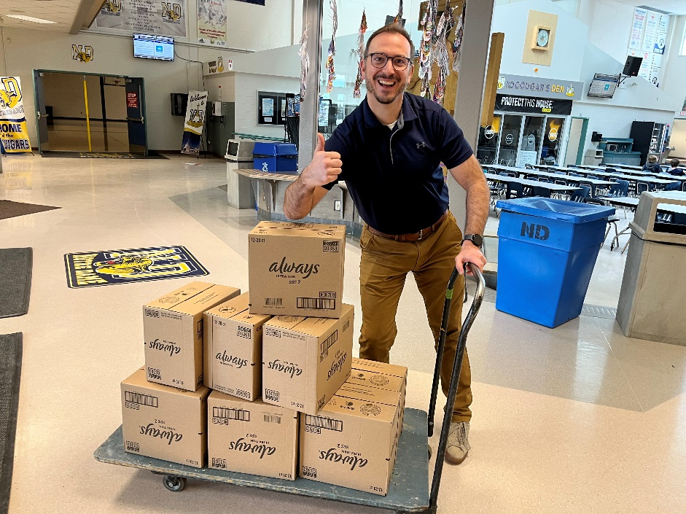
Notre Dame staff receiving P&G donation of period products for their students.

“When playing sports in school or going on field trips, or being a competitive swimmer, as well as a swimming coach, lifeguard and instructor, I frequently found myself in awkward situations whereby I didn’t have enough products or know when I might need products... I wanted to be recognized for my hard work and commitment, and I wanted to have the same access to what I needed to compete and meet my potential as an athlete, and sometimes I just had to exit the situation before completing what I wanted/needed to do.”
Let’s make a difference and help improve the health and well-being of people, making it easier for them to stay engaged in their communities and strengthen vital connections. If you haven yet had the chance, please consider donating and click the link here: https://www.justgiving.com/campaign/UWCAPeriodPromise2023

Kind Regards,
<<insert name>>

Email #3
Hello Team,

Campaign is three quarters through and we’ve done an amazing job so far. Thank you to everyone who has donated through the campaign page https://www.justgiving.com/campaign/UWCAPeriodPromise2023 or started their own fundraiser on JustGiving, or brought products in (or all!)!

As you know by now, there are many people struggling and too many people missing school or leaving work because they can’t afford to buy the products they need, and they are not freely available where they are needed.

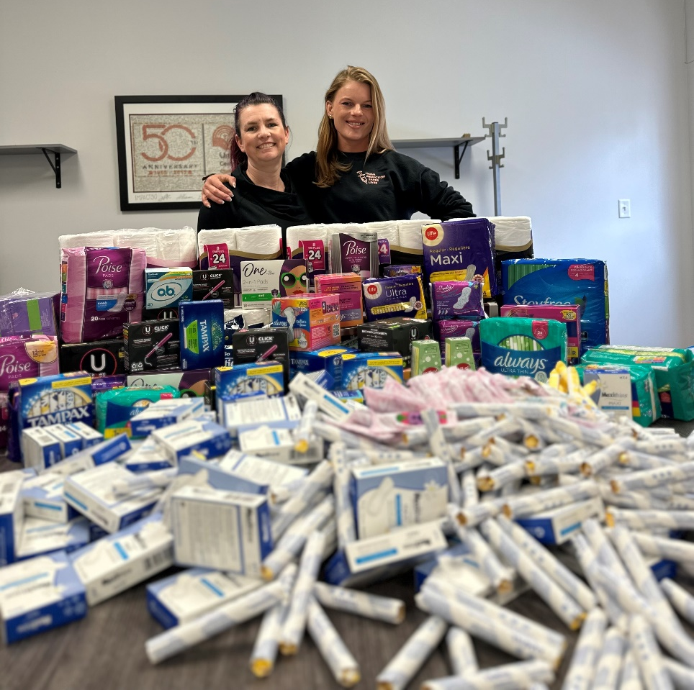
RDP Nursing Students with the products they collected to donate to Mountain Rose Centre in Rocky Mountain House.

Menstruation is one of the top two reasons that people who menstruate miss work; for many working in low income positions, that’s because they can’t afford to buy the product that they need because their family has to make tough choices every month. And it’s more common than you’d think. During their research project, United Way gathered hundreds of stories just like this one:

“I've missed work because the only thing to use was folded up toilet paper, I need to change that very often and am afraid of moving and having it fall down my pant leg. I've even lost jobs because I take time off once a month.”

Let’s be a part of the solution. Together, we can tackle period poverty and make our community more accessible for everybody. Here is our unique website link to donate:
https://www.justgiving.com/campaign/UWCAPeriodPromise2023

Thank you so much for your support.

Kind Regards,
<<insert name>>

Email #4
Hello Team,

As campaign draws to a close, we wanted to say thank you so much for all your contributions. We are so thrilled that we will be able to provide:
- xx tampons
- xx pads
- xx liners
- xx reusable products
- $xx in donations

Because of your generosity, United Way Central Alberta will be able to help the many people in our communities who face the additional challenges of homelessness, living with a disability, or just the stigma around having a period at all. People who are embarrassed to ask for help.

- Nearly 75% of people say that asking for help is made much harder because of menstrual stigma
- 30% of people say that they haven't known where to access menstrual products they could afford when their period has hit.
- Nearly 50% of people say that when they don’t have access the menstrual products they need when they need it, it affects their mental health by making them more anxious

Stories like these will be fewer and fewer:

“I was homeless as a teenager and later, I was a low-income single mother. I remember doing everything I could to make my supplies stretch- when I was homeless, I would often steal tampons after trying to find some for free. When I was a young, poor single mother, every penny spent was towards my daughter- I would bus for hours to try to find free menstrual supplies. I would use old rags. I would wear a tampon for way, way longer than I should've. It was food for my baby or tampons, so I chose food for my baby.”

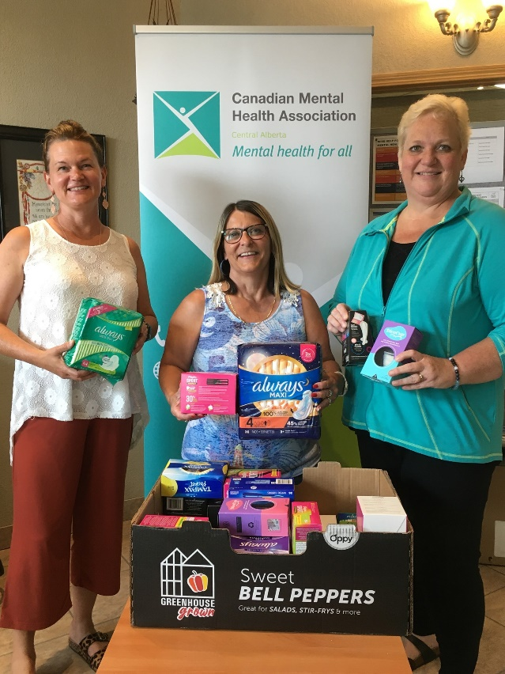
A United Way volunteer delivering a hamper full of menstrual products to a community agency on behalf of the Period Promise campaign!

Once again, thank you for your kindness and generosity. We are helping build the vital connections that help make our communities stronger.

Kind Regards,
<<insert name>>

